**1.Write a c program to evaluate the code for minimum spanning tree**

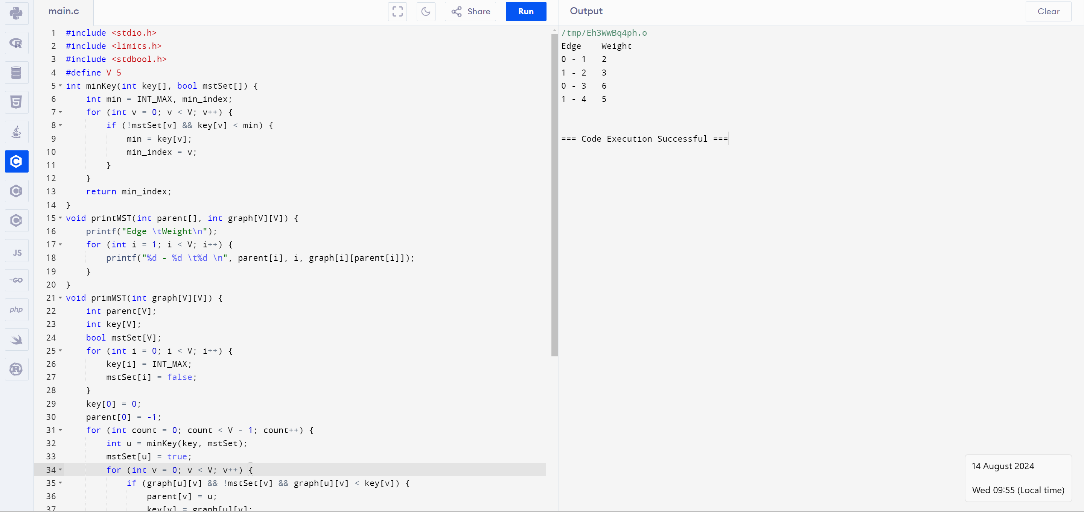

**2.Write a c program to evaluate the code for prims algorithm**



**3.Write a c program to evaluate the code for krushkal algorithm**

